6 | An online food delivery platform enables customers to browse restaurants, view menus, place food orders, make online payments, and track delivery status. Restaurants use the system to manage their menus and update order status, while delivery agents are responsible for accepting delivery requests and updating delivery progress. Design a Class Diagram, Use case Diagram and Activity Diagram for the Online Food Delivery System showing the relevant classes, their attributes, methods, and relationships. | Umbrello | CO1

Objective
To design UML diagrams (Class, Use Case, and Activity) for an Online Food Delivery System using Umbrello, representing system functionality, structure, and workflow.(mythresree,losane)

System Description (Short)
The Online Food Delivery System allows:
- Customers → browse restaurants, order food, make payments, track delivery
- Restaurants → manage menu and update order status
- Delivery Agents → accept orders and update delivery progress

🔹 PART 1: CLASS DIAGRAM

Step 1: Open Umbrello
- Open Umbrello UML Modeller
- Click File → New

Step 2: Select Class Diagram
- In left panel → Right click Logical View
- Select New Diagram → Class Diagram
- Rename as:
👉FoodDelivery_ClassDiagram

Step 3: Add Classes
Click Class icon and create:
- Customer
- Restaurant
- Menu
- FoodItem
- Order
- Payment
- DeliveryAgent

Step 4: Add Attributes & Methods
Customer
- customerId
- name
- address
- phone
Methods:
- browseRestaurants()
- placeOrder()
- makePayment()
- trackOrder()

Restaurant
- restaurantId
- name
- location
Methods:
- updateMenu()
- acceptOrder()

Menu
- menuId
Methods:
- showItems()

FoodItem
- itemId
- itemName
- price

Order
- orderId
- status
Methods:
- updateStatus()

Payment
- paymentId
- amount
- paymentStatus
Methods:
- processPayment()

DeliveryAgent
- agentId
- name
Methods:
- acceptDelivery()
- updateDeliveryStatus()

Step 5: Draw Relationships
Use Association / Aggregation lines:
- Customer → Order
- Restaurant → Menu
- Menu → FoodItem
- Order → Payment
- Order → DeliveryAgent

Step 6: Save Diagram
File → Save as FoodDelivery_ClassDiagram.uxf

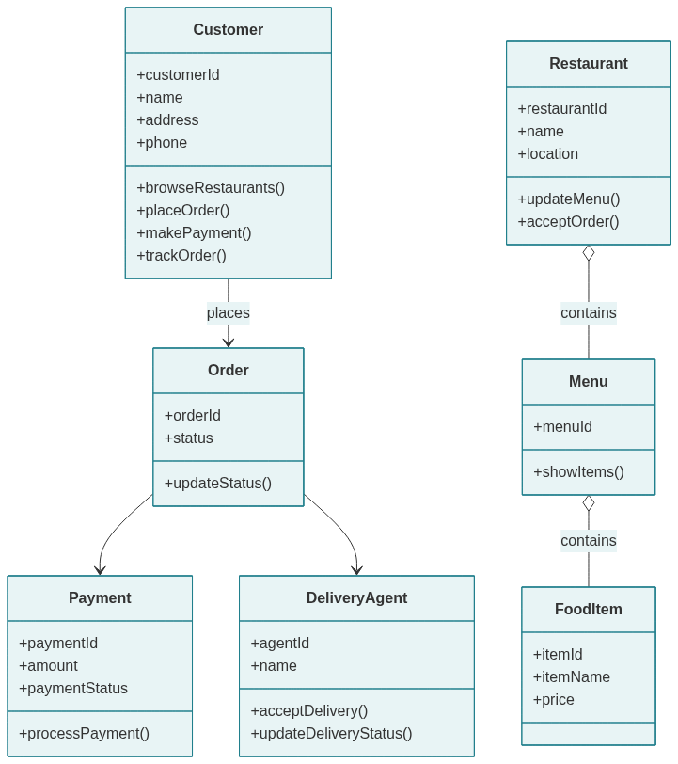

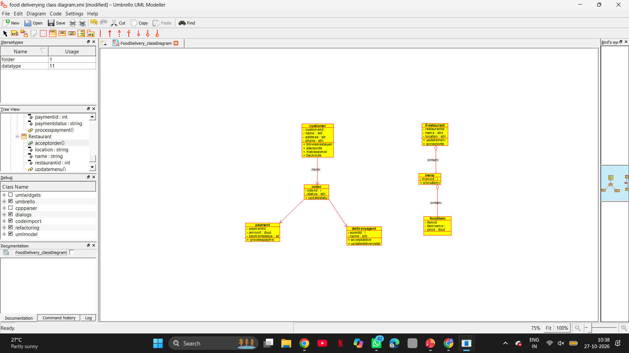

🔹 PART 2: USE CASE DIAGRAM

Step 1: Create Use Case Diagram
Right click Use Case View → New Diagram
Rename as: FoodDelivery_UseCaseDiagram

Step 2: Add Actors
Add:
- Customer
- Restaurant
- Delivery Agent

Step 3: Add Use Cases
Customer Use Cases
- Browse Restaurants
- View Menu
- Place Order
- Make Payment
- Track Delivery

Restaurant Use Cases
- Manage Menu
- Update Order Status

Delivery Agent Use Cases
- Accept Delivery
- Update Delivery Status

Step 4: Connect Actors to Use Cases
Use Association line:
- Customer → all customer use cases
- Restaurant → manage menu, update order
- Delivery Agent → delivery tasks

Step 5: Save Diagram
Save as: FoodDelivery_UseCaseDiagram.uxf

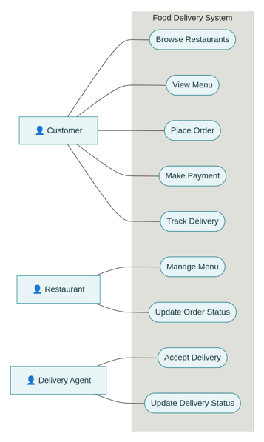
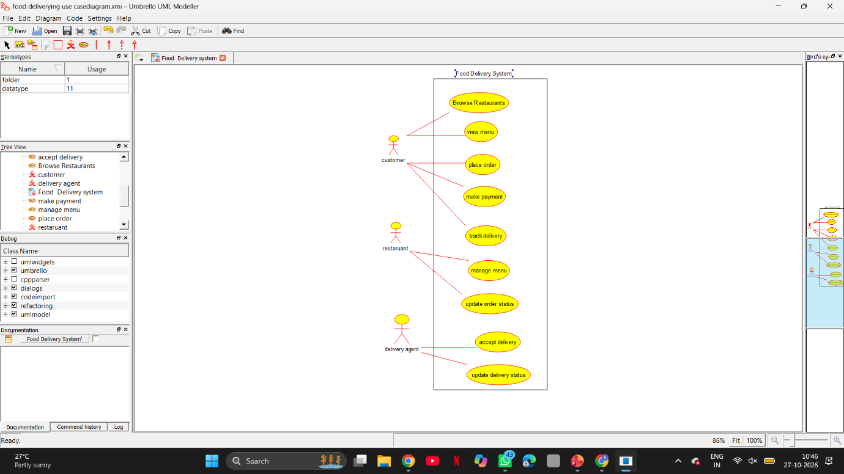

🔹 PART 3: ACTIVITY DIAGRAM

Step 1: Create Activity Diagram
Right click Logical View → New Diagram → Activity Diagram
Rename as: FoodDelivery_ActivityDiagram

Step 2: Add Activities in Sequence
- Start
- Browse Restaurants
- View Menu
- Select Food
- Place Order
- Make Payment
- Order Confirmed
- Restaurant Prepares Food
- Delivery Agent Picks Order
- Deliver Food
- Order Completed
- Stop

Step 3: Connect Flow
Use Control Flow arrows to connect each activity in order.

Step 4: Save Diagram
Save as: FoodDelivery_ActivityDiagram.uxf
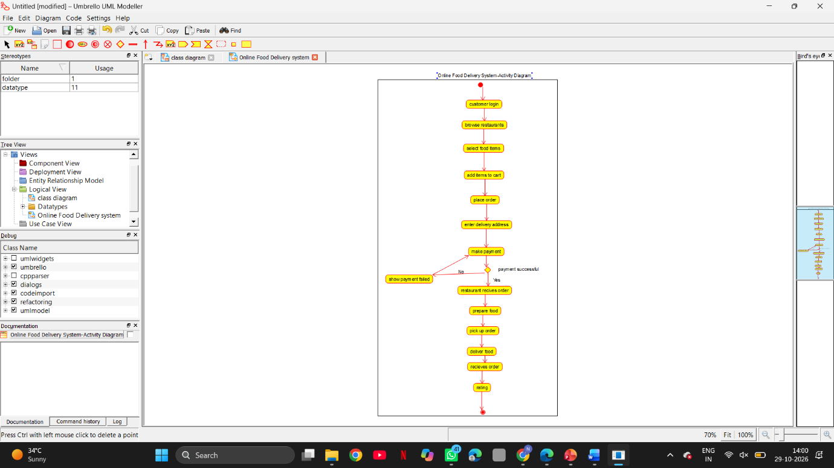

Result
Thus, Class Diagram, Use Case Diagram, and Activity Diagram for the Online Food Delivery System were successfully designed using Umbrello UML Modeller.

